ANTI –PIRACY PHOTOS
MT. OCEAN ENERGY DATE:02nd MAY 2015
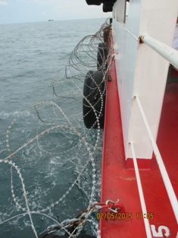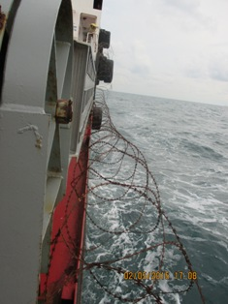

POOP DECK PORT POOP DECK STBD

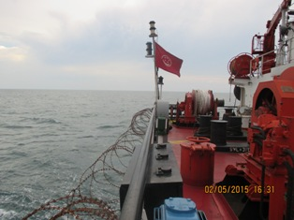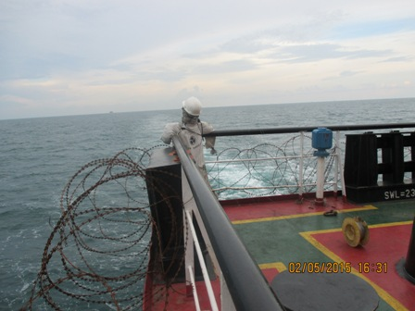
AFT SIDE DUMMY AFT STBD SIDE

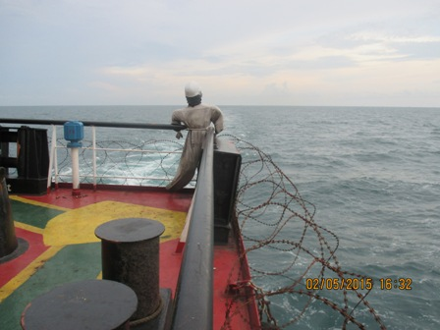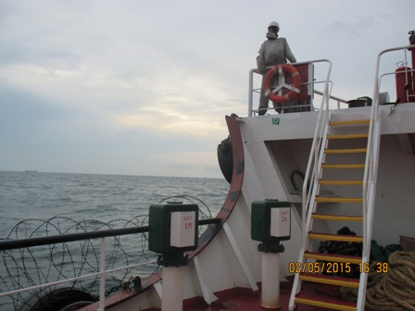
DUMMY AFT PORT SIDE DUMMY FORCASTLE PORT

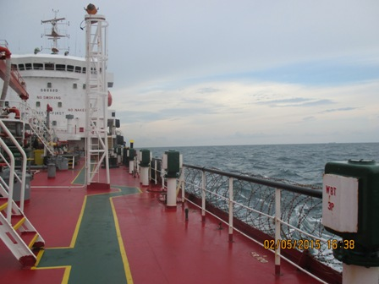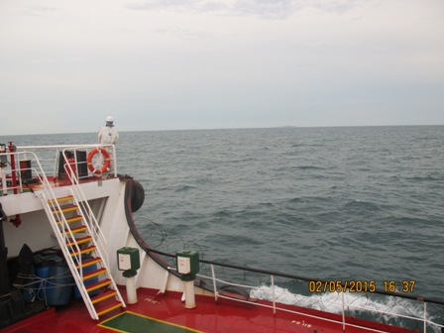
MAIN DECK STBD DUMMY FORCASTLE STBD
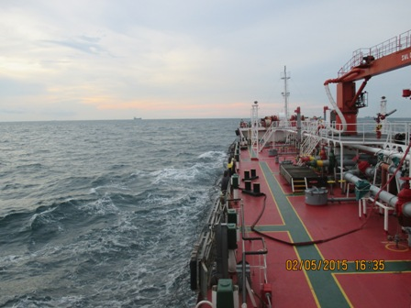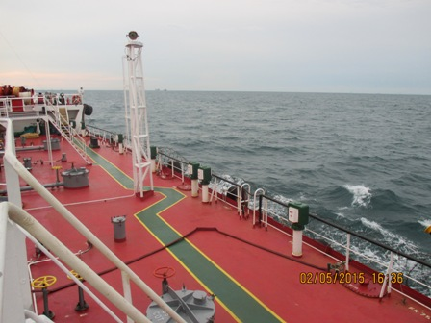
FIRE HOSE PORT MAIN DECK FIRE HOSE STBD MAIN DECK

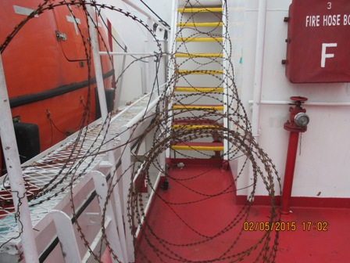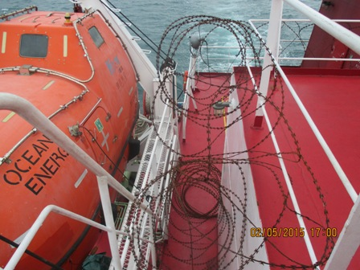

DECK TO BRIGE STARWAY 1 DECK TO BRIGE STARWAY
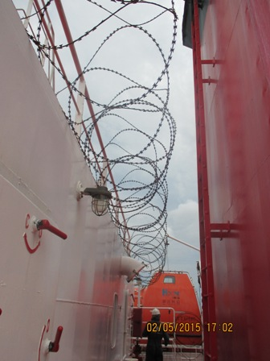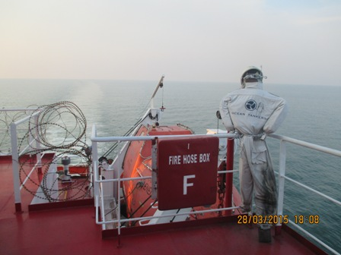
PANNEL DUMMY BRIDGE PORT/SIDE

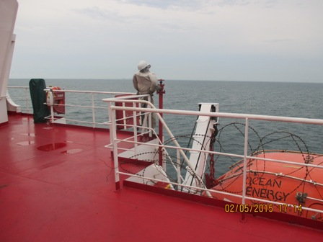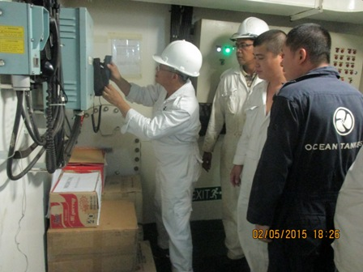
DUMMY BRIGDE STBD/ ANTI-PIRACY DRILL

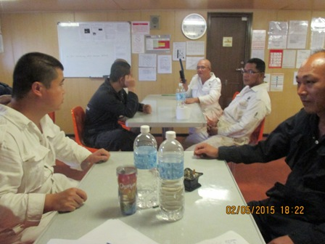
EXTRAORDINARY SAFETY MEETING

